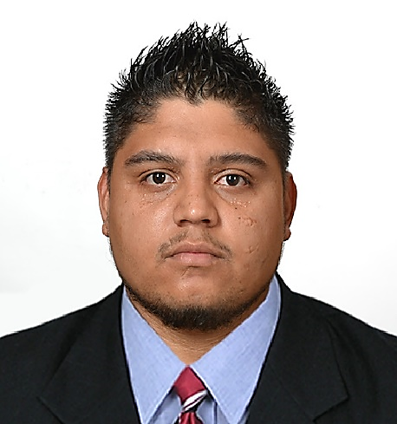

*32 Helm Drive, Westmooring, Port of Spain. Trinidad & Tobago*

**Spanish:**

**English:**

**Microsoft office:**

**Easy to Learn:**

**Languages and skills**

**0 100**

**outstanding achievement**

Approve the internship report with a high score.

**Entrepreneur, Rodriguez Alvarez transport**

*Owner of my own business.*

*Guarantee good service to the customers.*

*Ensure that everything work good.*

**From 2017 to Present**

**From: Sep 2013 to Nov 2013**

**Intern, Weatherford labs:**

*Receive samples from the customers*

*Help to perform the analysis test.*

*Take results.*

**2009 - 2014**

**1994 - 2007**

**Petroleum Engineer**

*Santiago Marino University, Ojeda City, Venezuela*

**Bachelor of Science.**

*Miguel Acosta Saignes School, Ojeda City, Venezuela*

**Passport ID: 126094699 Nationality: Venezuelan**

**Age: 27 Phone: 868-3936799 E-mail: Franklinrjl_03@hotmail.com**

**Experience**

**Educational Information**

I am a young professional from Venezuela graduated as a petroleum engineer in 2014, but I am looking for a job opportunity that can help me to grow occupationally, my skills are that I can speak two languages (Spanish and English), some computer skills, self-motivated, committed and responsible.

**EXTRACTO PROFESIONAL**

**Franklin J. Rodríguez L**

*Petroleum Engineer*